Brit Stevens 5/23/24

GNS Virtual Router Configuration

**Purpose:**

the purpose of this lab was to introduce a stronger sense of what virtualization is capable of with the use of GNS3 simulating our network. It also introduced the concept of segmentation of network traffic within one physical topology with the use of VRF configurations. Combining these topics creates a more challenging lab that teaches us both the concepts fully as we research them.

**Background Information on lab concepts:**

* **Virtualization** 
  + **Virtualization** is the process of moving physical hardware to virtualized with either cloud resources or emulated on fewer physical devices than previous. Virtualization has many benefits as it typical reduces costs, ensures greater utilization of your hardware, and allows for more scalability of your network/infrastructure without the need for a much greater amount of hardware.
  + **Gns3: Graphic Network Simulator-3** is a software that can be used as an emulator for numerous things. For example a network going between different companies using VRF. Unlike other emulators, GNS3 can combine virtualized devices with real network adapters on your host machine.
  + **Solar PuTTy** is a standalone CLI/terminal emulator That can support SSH, telnet, And the device’s console. To use GNS 3 you must use solar-puTTy with it. Solar-PuTTy is an enhanced original puTTy which includes multiple session management, credential savings, and auto reconnect.
  + **Virtual machines** 
    - **Gui vs CLI based VMs:** The GUI is easier to learn and use especially for people of less networking experience, provides visual elements like windows icons menus; things that you can click while the CLI requires users to type commands, commits changes faster and offers higher precision and allows automation and scripting. This CLI is preferred by professionals for the ability of that greater control. The Cisco access point is one of the devices that is preferred to edit in the CLI by many but for the slab we chose to use the GUI when we could.
    - **Oracle Virtual Box** is an open-source virtualization software that allows users to run multiple operating systems on a single device. It has a dashboard that allows for easy configuration of these virtual machines four areas as ram allocation, type of VM, and the physical properties of the host that It can access. In this dashboard you can also manage which VMS are running and have an overview of all VMS using Oracle VirtualBox. There are other options like windows hypervisor but we chose Oracle because it has greater integration with GNS3.
  + **Virtualized routers** such as the ones used in GNS3 allow for emulation of your network with a router model and OS of your choice. The files to add your virtualized router are relatively easy to find if you go to official sites like cisco.com.
    - **Duplex modes:** There are three different duplex modes: Full, Auto, and Half. In full duplex mode, the ports on a router can send data and receive data at the same time. This is standard for almost all devices now, but it is important to check your configs to ensure it is enabled. In auto duplex mode your device negotiates with the device on the other end to determine which duplex mode to configure the port as. In half duplex mode, data can only be sent one direction, meaning it can only be received or sent by a device, not both at the same time. The ports on our router were configured this way by default, requiring us to change the ports to full duplex.
* **VRF**
  + **Uses of VRF in a network**
    - VRF is a protocol that allows multiple instances of routing table to coexist within a router, causing a separation of data and visible networks between the different VRF areas. VRF is an example of segmentation of network which used to increase the security of your network. One example of this could be separating customer traffic from business traffic while using the same router.
  + **Advantages of VRF**
    - As previously mentioned VRF provides isolation of networks increasing the security and reducing the risk of unwanted users in a network. VRF also allows for the scalability and flexibility of the network to increase. By using VRF, you can have the same subnet ranges and addresses on both sides of the VRF area letting you have more users or end devices in total. This also allows for greater control of your network as you could apply routing policies just to one VRF area and have separate routing policies for the other VRF area. This could reduce the need of additional routers as you could use VRF areas to act as an additional router.

**Required Resources:**

* ***Desktop.***
* ***GNS3 with Virtual Machine.***
* ***Cisco 7200 Router Image File.***
* ***Virtual Machine Platform.***

**Lab Commands:**

**Router Commands:**

* VRF Configuration (Global Configuration Mode)
  + IP vrf ‘word’ (This command creates a VRF under the word you entered and enters VRF configuration).
    - Rd ‘x:y’ (This command is to distinguish between different VRFs with of value of ‘x’ and ‘y’. The ‘x’ could be an AS number or an IP address while ‘y’ is any number to identify within that ‘x’ value).
  + Interface ‘x’
    - IP vrf forwarding ‘name’ (This sets an interface to associate and only forward data from that VRF out).
  + Router ospf ‘x’ vrf ‘word’ (This enters the configurations for OSPF with the specification that it is used only for a certain VRF specified with the name of the VRF entered in ‘word’. The ‘x’ must be a different value for different VRFs).
* Router Functions (Interface Configuration Mode)
  + Duplex ‘full/half/auto’ (There were older port adapters on the routers so configuring Duplux was required. This command sets your Duplex to full, half, or auto depending on what you want).

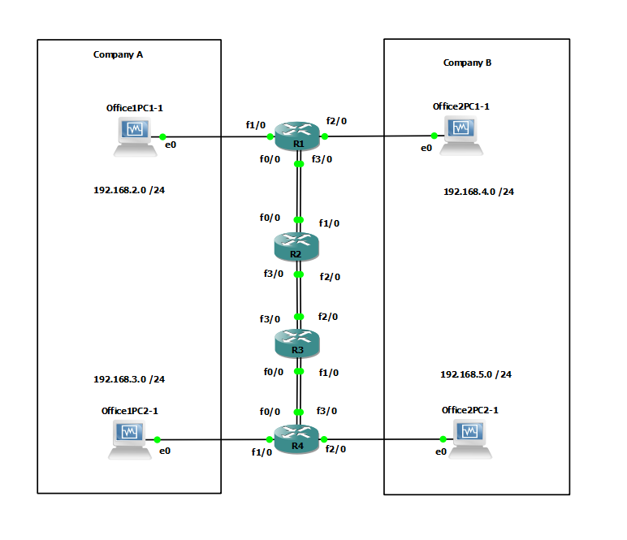

**Lab Summary:**

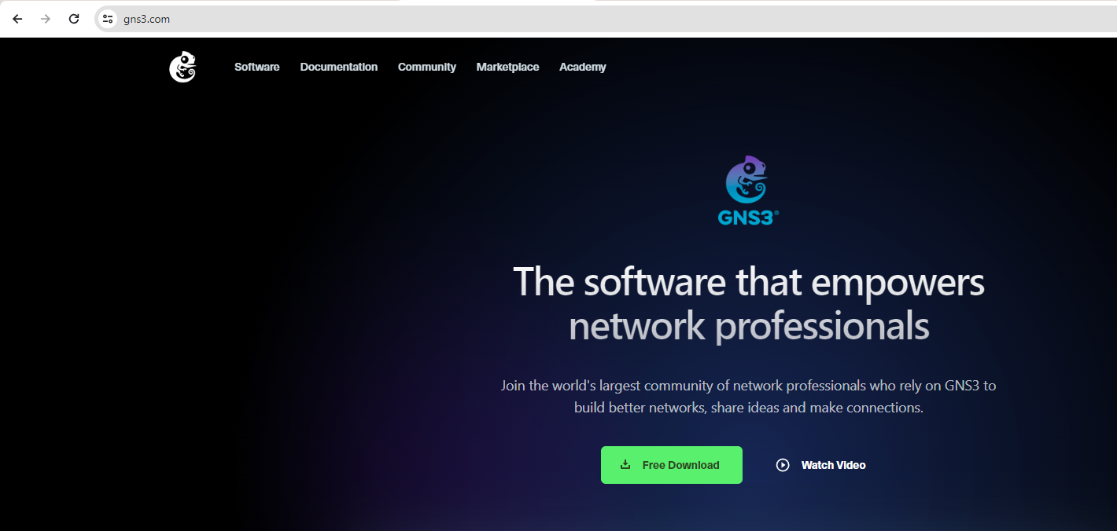

First open a web browser to the GNS3 website and download the application.

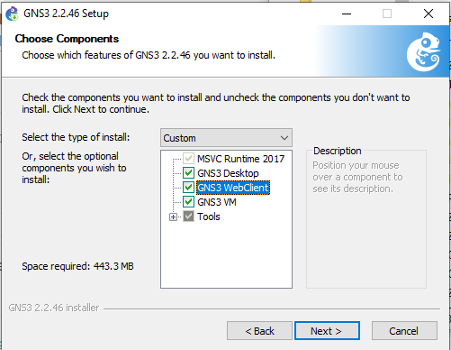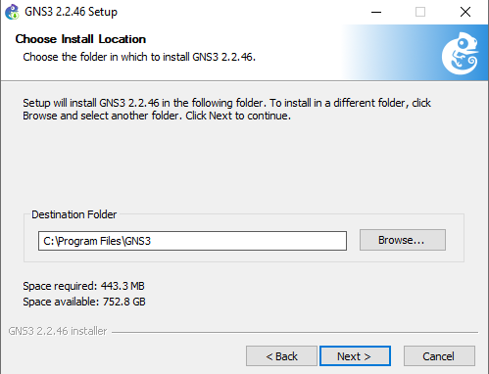

Ensure you enable GNS3 Desktop and VM as both will be used for this lab. You will receive a Prompt to download Solar-PuTTy, agree and download after making an account to allow access to the CLI for the routers.

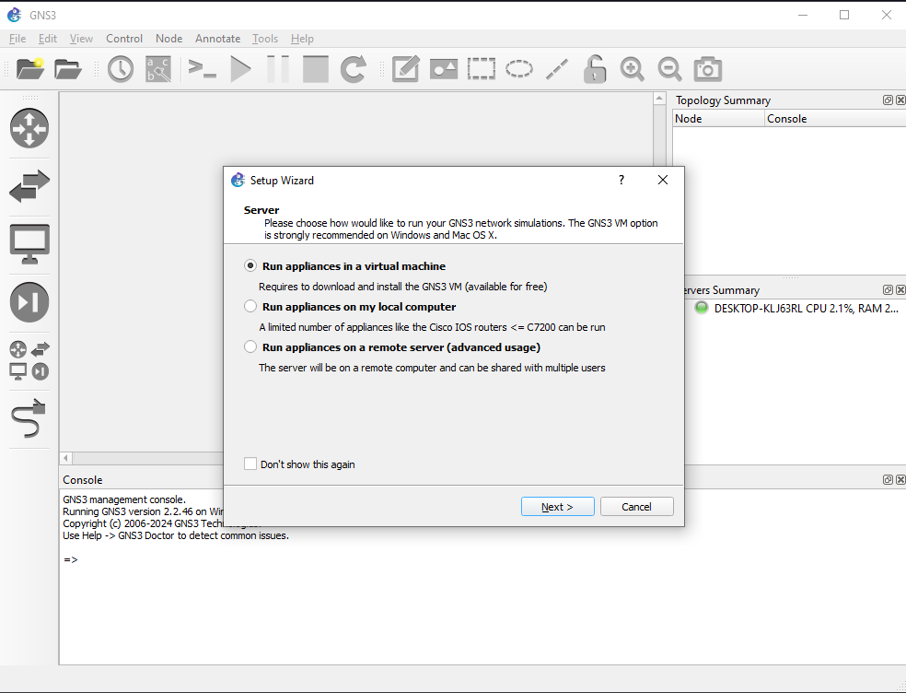

Select run applications on a virtual machine when you open GNS3 to utilize the VMs we will make.

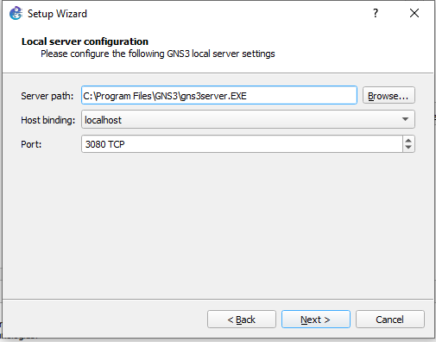

Bind your local server to localhost.

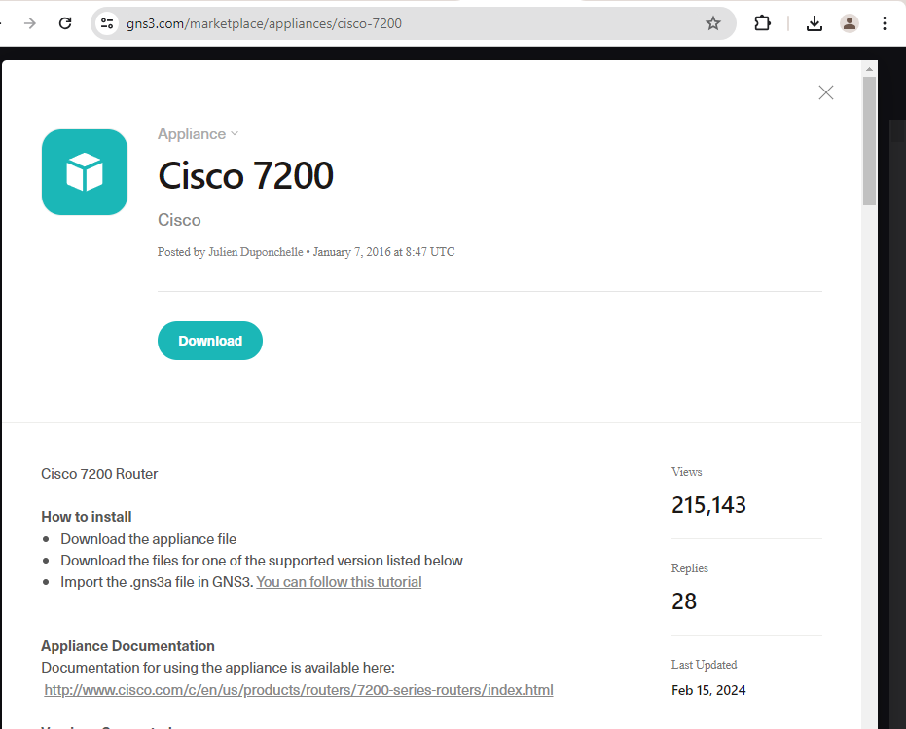

Open the GNS3 website again and navigate to the marketplace. Search for Cisco 7200 and download the application. You will need to find the router file as well; this is just to run the file.



Once downloaded, double Click to open the file in GNS3.

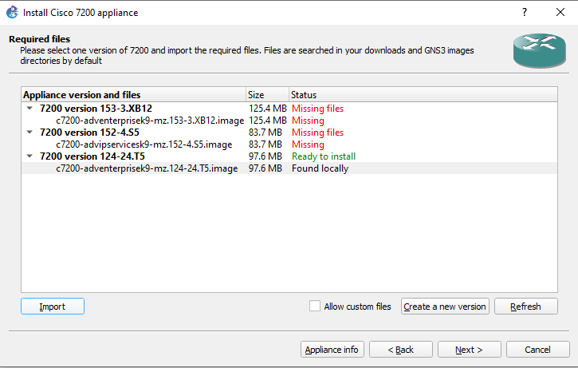

Once it opens you will see the following install window. Click on one of the following image files and import your matching image file to it. This will allow the use of that router in your GNS3 project. Click yes to the install prompt. You can now begin making the topology.

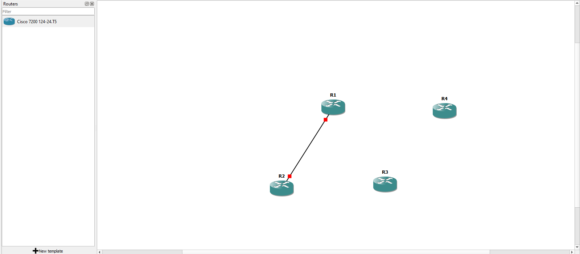

On the left-hand navigation bar look for the routers. You should now see the router image you imported. Click and drag four routers into your project window.

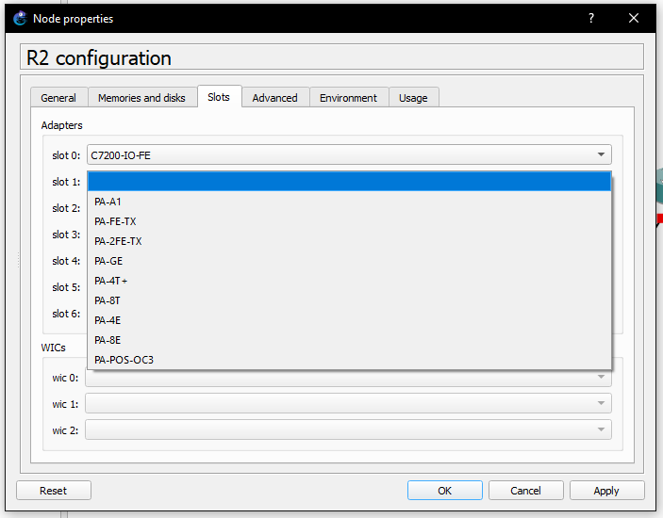

Click and select configure to begin configuring your routers. By default, these routers only have one slot adapter so we will need to three add more. Navigate to the slots section and add your preferred slot adapter. For this lab we used 3 PA-FE-TX additional to the preconfigured adapter.

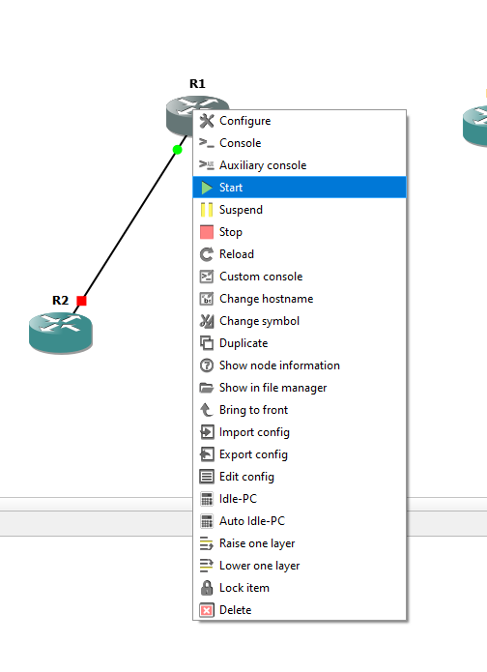

Select all your routers, right click and select start to boot them. We now have the router portion of the topology set up.

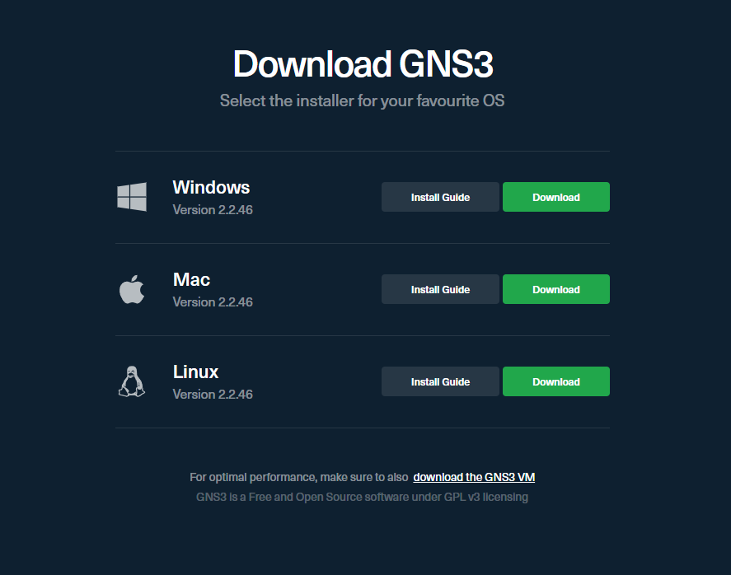

from the GNS3 download page you can download a virtual machine of your choosing by selecting the download link below the GNS3 download options.

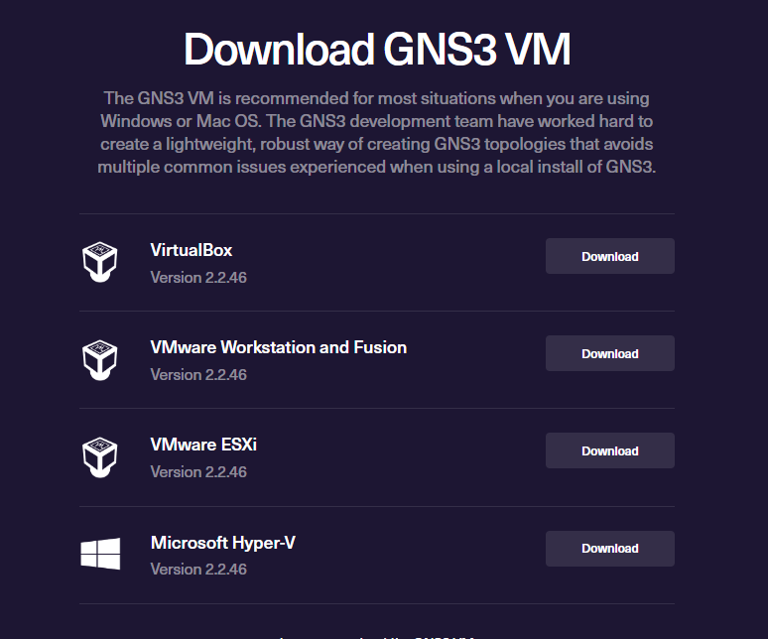

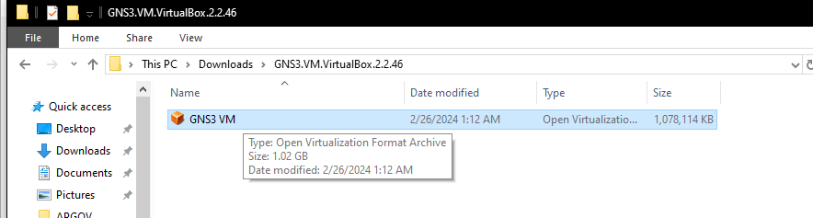

You can choose your preferred virtual machine manager; for this lab, we're using VirtualBox. This will be a text-based virtual machine that you can configure like any real host machine. Since we are unfamiliar with this kind of user interface, we're going to use a Windows GUI virtual machine.

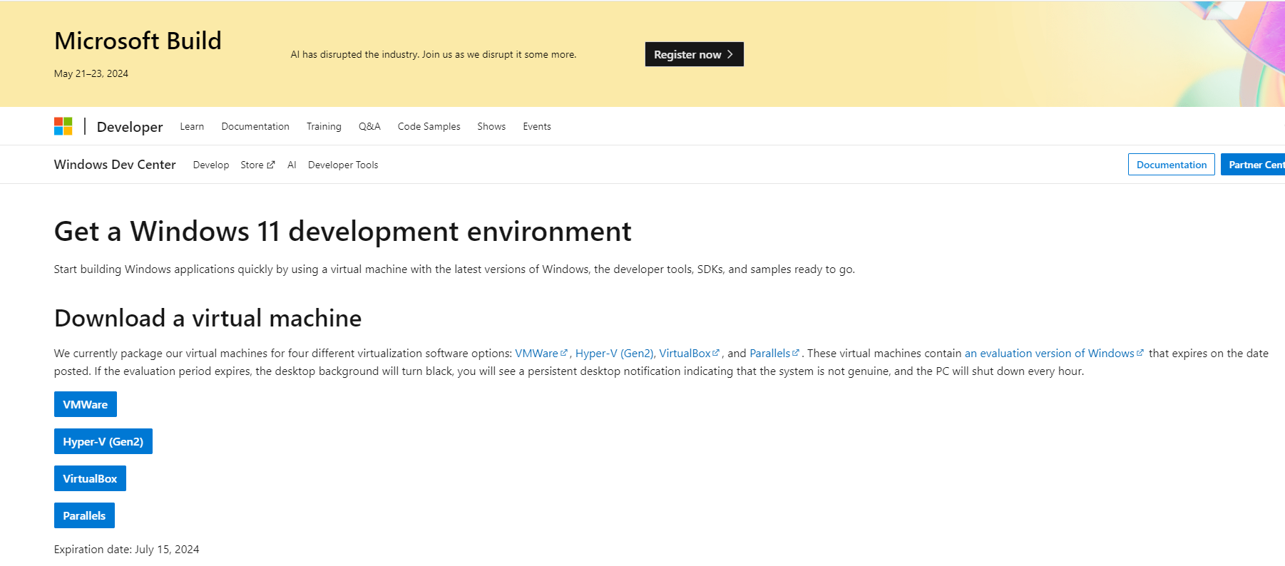

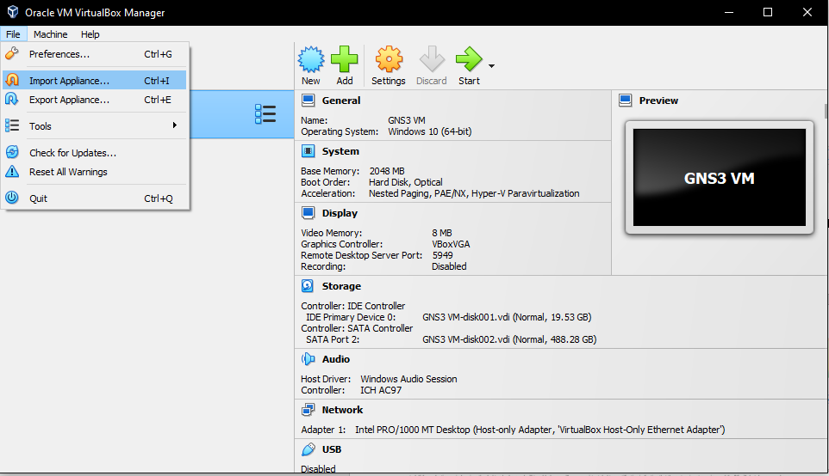

After finding and downloading your GUI virtual machine open VirtualBox -> file -> import appliance to import your virtual machine image.

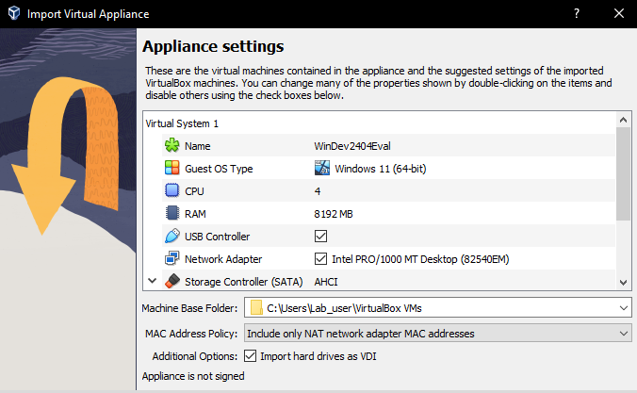

once you select import you can change the settings of the virtual machine to what you need, or it can run based on your host machine running the VM. This will take some time to import.

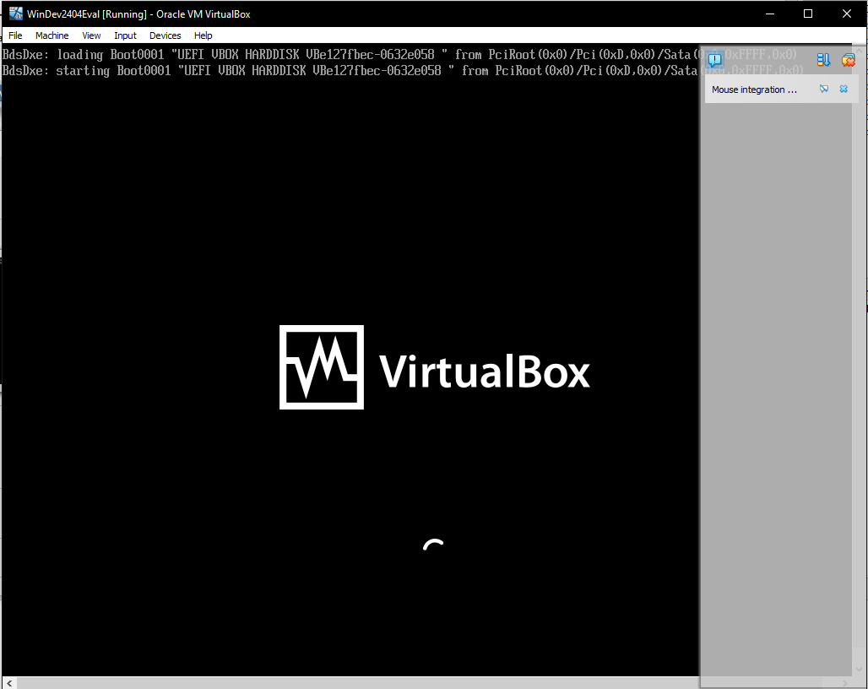On the dashboard you can select Start to run the virtual machines and allow them to run the first time boot set up as a real host machine would need to.

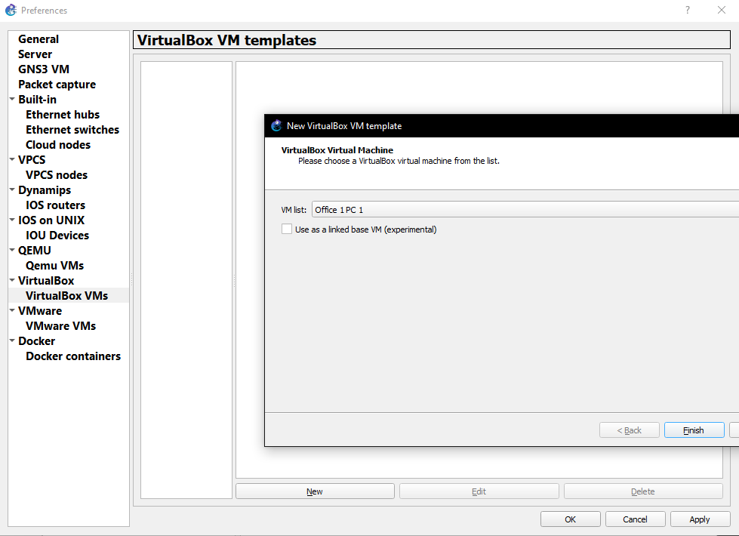

to import this VM into GNS3, navigate to edit -> preferences -> VirtualBox -> VirtualBox VMs and click new. You should see a list including all the VMs you imported into VirtualBox. Select the ones you want to use and click finish.

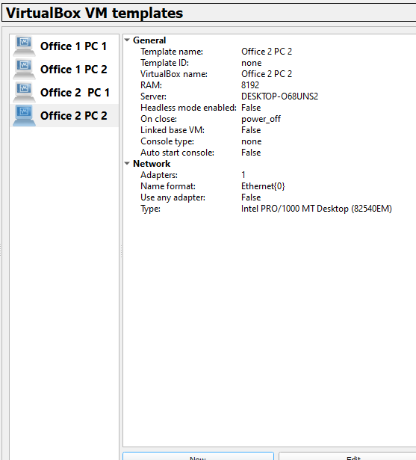

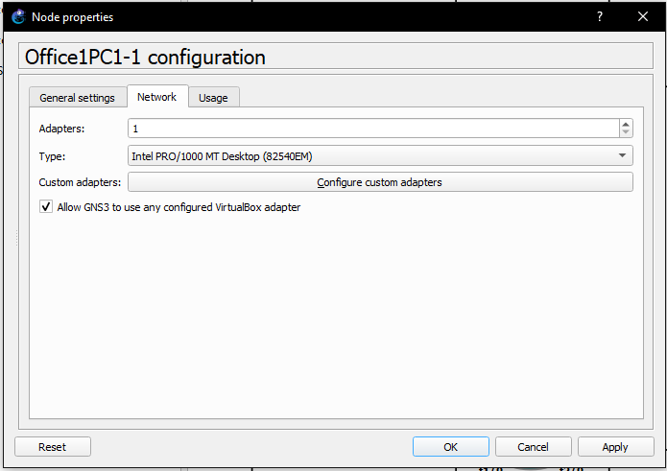Click and drag your VMs into the project window and right Click to configure them. Under network settings ensure you have the toggle box to allow GNS 3 to use any configured VirtualBox adapter. This will let your VM connect to any port on your virtualized router.

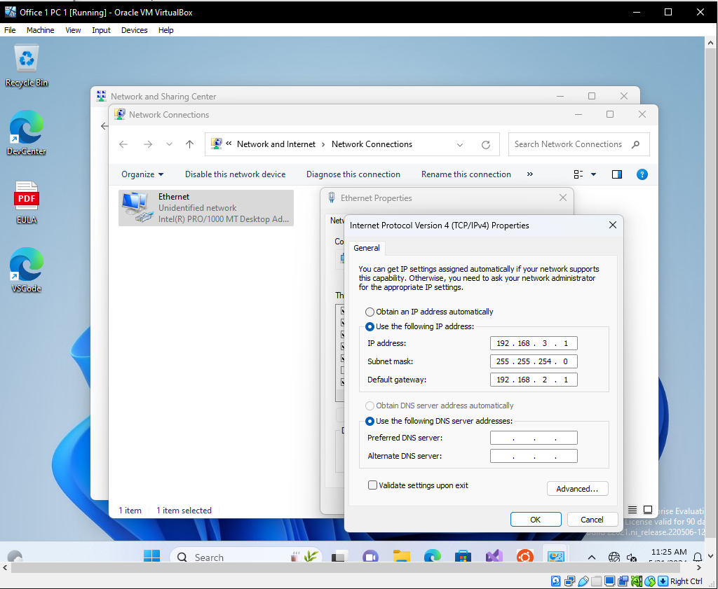

Inside the VM configure for use by going to control panel -> network settings -> Ethernet properties -> IPv4 and assign an IP in the range of the subnet you put your VM into.

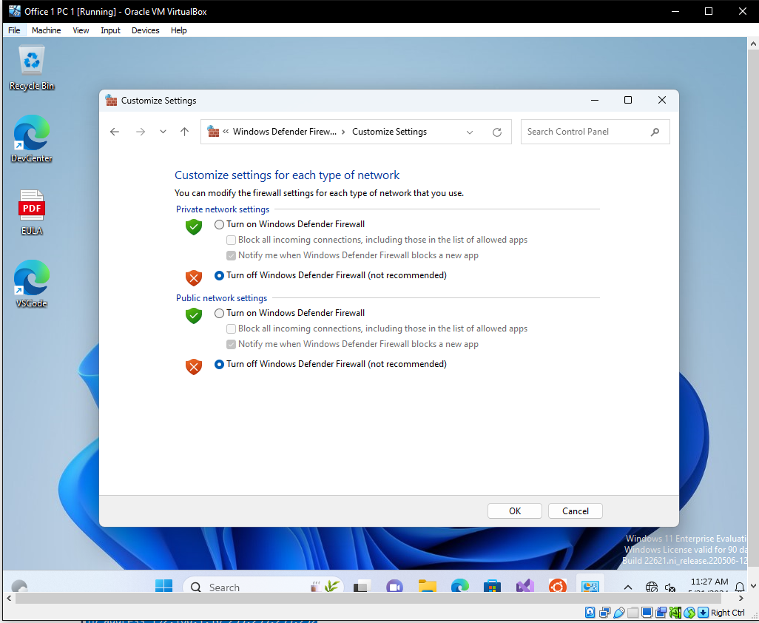

double check that the firewall on the VM is off as it may block the ping. Using the commands for the routers previously listed you should now be able to ping out within the same VRF area.

**Verification:**

Company A PCs can ping each other shown through the trace routes but cannot ping company B PCs due to them being in a different VRF area. Company B PCs are configured the same but can only ping between Company B PCs and cannot access the Company A VRF area.

**Company A PC 1:**

C:\Users\User>tracert 192.168.3.2

Tracing route to 192.168.3.2 over a maximum of 30 hops

1 11 ms 3 ms 7 ms 192.168.2.1

2 32 ms 31 ms 28 ms 192.168.1.2

3 49 ms 54 ms 46 ms 192.168.1.6

4 68 ms 62 ms 57 ms 192.168.1.10

5 86 ms 84 ms 80 ms 192.168.3.2

Trace complete.

C:\Users\User>ping 192.168.4.2

Pinging 192.168.4.2 with 32 bytes of data:

Reply from 192.168.2.1: Destination host unreachable.

Reply from 192.168.2.1: Destination host unreachable.

Reply from 192.168.2.1: Destination host unreachable.

Reply from 192.168.2.1: Destination host unreachable.

Ping statistics for 192.168.4.2:

Packets: Sent = 4, Received = 4, Lost = 0 (0% loss),

C:\Users\User>ping 192.168.5.2

Pinging 192.168.5.2 with 32 bytes of data:

Reply from 192.168.2.1: Destination host unreachable.

Reply from 192.168.2.1: Destination host unreachable.

Reply from 192.168.2.1: Destination host unreachable.

Reply from 192.168.2.1: Destination host unreachable.

Ping statistics for 192.168.5.2:

Packets: Sent = 4, Received = 4, Lost = 0 (0% loss),

**Company A PC 2:**

C:\Users\User>tracert 192.168.2.2

Tracing route to 192.168.2.2 over a maximum of 30 hops

1 8 ms 7 ms 7 ms 192.168.3.1

2 29 ms 23 ms 29 ms 192.168.1.9

3 46 ms 46 ms 48 ms 192.168.1.5

4 76 ms 70 ms 67 ms 192.168.1.1

5 82 ms 84 ms 77 ms 192.168.2.2

Trace complete.

C:\Users\User>tracert 192.168.4.2

Tracing route to 192.168.4.2 over a maximum of 30 hops

1 10 ms 10 ms 5 ms ^C

C:\Users\User>ping 192.168.4.2

Pinging 192.168.4.2 with 32 bytes of data:

Reply from 192.168.3.1: Destination host unreachable.

Reply from 192.168.3.1: Destination host unreachable.

Reply from 192.168.3.1: Destination host unreachable.

Reply from 192.168.3.1: Destination host unreachable.

Ping statistics for 192.168.4.2:

Packets: Sent = 4, Received = 4, Lost = 0 (0% loss),

C:\Users\User>ping 192.168.5.2

Pinging 192.168.5.2 with 32 bytes of data:

Reply from 192.168.3.1: Destination host unreachable.

Reply from 192.168.3.1: Destination host unreachable.

Reply from 192.168.3.1: Destination host unreachable.

Reply from 192.168.3.1: Destination host unreachable.

Ping statistics for 192.168.5.2:

Packets: Sent = 4, Received = 4, Lost = 0 (0% loss),

**Company B PC 1:**

C:\Users\User>tracert 192.168.5.2

Tracing route to 192.168.5.2 over a maximum of 30 hops

1 12 ms 5 ms 7 ms 192.168.4.1

2 30 ms 25 ms 23 ms 192.168.1.2

3 44 ms 51 ms 52 ms 192.168.1.6

4 73 ms 72 ms 68 ms 192.168.1.10

5 76 ms 80 ms 80 ms 192.168.5.2

Trace complete.

C:\Users\User>ping 192.168.2.2

Pinging 192.168.2.2 with 32 bytes of data:

Reply from 192.168.4.1: Destination host unreachable.

Reply from 192.168.4.1: Destination host unreachable.

Reply from 192.168.4.1: Destination host unreachable.

Reply from 192.168.4.1: Destination host unreachable.

Ping statistics for 192.168.2.2:

Packets: Sent = 4, Received = 4, Lost = 0 (0% loss),

C:\Users\User>ping 192.168.3.2

Pinging 192.168.3.2 with 32 bytes of data:

Reply from 192.168.4.1: Destination host unreachable.

Reply from 192.168.4.1: Destination host unreachable.

Reply from 192.168.4.1: Destination host unreachable.

Reply from 192.168.4.1: Destination host unreachable.

Ping statistics for 192.168.3.2:

Packets: Sent = 4, Received = 4, Lost = 0 (0% loss),

**Company B PC 2:**

C:\Users\User>tracert 192.168.4.2

Tracing route to 192.168.4.2 over a maximum of 30 hops

1 9 ms 8 ms 6 ms 192.168.5.1

2 31 ms 28 ms 27 ms 192.168.1.9

3 48 ms 53 ms 47 ms 192.168.1.5

4 73 ms 71 ms 71 ms 192.168.1.1

5 89 ms 82 ms 85 ms 192.168.4.2

Trace complete.

C:\Users\User>ping 192.168.2.2

Pinging 192.168.2.2 with 32 bytes of data:

Reply from 192.168.5.1: Destination host unreachable.

Reply from 192.168.5.1: Destination host unreachable.

Reply from 192.168.5.1: Destination host unreachable.

Reply from 192.168.5.1: Destination host unreachable.

Ping statistics for 192.168.2.2:

Packets: Sent = 4, Received = 4, Lost = 0 (0% loss),

C:\Users\User>ping 192.168.3.2

Pinging 192.168.3.2 with 32 bytes of data:

Reply from 192.168.5.1: Destination host unreachable.

Reply from 192.168.5.1: Destination host unreachable.

Reply from 192.168.5.1: Destination host unreachable.

Reply from 192.168.5.1: Destination host unreachable.

Ping statistics for 192.168.3.2:

Packets: Sent = 4, Received = 4, Lost = 0 (0% loss),

**Configurations and Routing Tables:**

**R1 Running Configuration:**

Building configuration...

Current configuration : 1663 bytes

upgrade fpd auto

version 12.4

service timestamps debug datetime msec

service timestamps log datetime msec

no service password-encryption

hostname R1

boot-start-marker

boot-end-marker

logging message-counter syslog

no aaa new-model

ip source-route

no ip icmp rate-limit unreachable

ip cef

ip vrf COA

rd 1:1

ip vrf COB

rd 2:2

no ip domain lookup

no ipv6 cef

multilink bundle-name authenticated

archive

log config

hidekeys

ip tcp synwait-time 5

interface FastEthernet0/0

ip vrf forwarding COA

ip address 192.168.1.1 255.255.255.252

duplex full

interface FastEthernet1/0

ip vrf forwarding COA

ip address 192.168.2.1 255.255.255.0

duplex full

interface FastEthernet2/0

ip vrf forwarding COB

ip address 192.168.4.1 255.255.255.0

duplex full

interface FastEthernet3/0

ip vrf forwarding COB

ip address 192.168.1.1 255.255.255.252

duplex full

router ospf 1 vrf COA

log-adjacency-changes

passive-interface FastEthernet1/0

network 192.168.1.0 0.0.0.3 area 1

network 192.168.2.0 0.0.0.255 area 1

default-information originate

router ospf 2 vrf COB

log-adjacency-changes

passive-interface FastEthernet2/0

network 192.168.1.0 0.0.0.3 area 1

network 192.168.4.0 0.0.0.255 area 1

default-information originate

ip forward-protocol nd

no ip http server

no ip http secure-server

no cdp log mismatch duplex

control-plane

gatekeeper

shutdown

line con 0

exec-timeout 0 0

privilege level 15

logging synchronous

stopbits 1

line aux 0

exec-timeout 0 0

privilege level 15

logging synchronous

stopbits 1

line vty 0 4

login

end

**R1 IP Route VRF COA:**

R1#show ip route vrf COA

Routing Table: COA

Codes: C - connected, S - static, R - RIP, M - mobile, B - BGP

D - EIGRP, EX - EIGRP external, O - OSPF, IA - OSPF inter area

N1 - OSPF NSSA external type 1, N2 - OSPF NSSA external type 2

E1 - OSPF external type 1, E2 - OSPF external type 2

i - IS-IS, su - IS-IS summary, L1 - IS-IS level-1, L2 - IS-IS level-2

ia - IS-IS inter area, * - candidate default, U - per-user static route

o - ODR, P - periodic downloaded static route

Gateway of last resort is not set

192.168.1.0/30 is subnetted, 3 subnets

O 192.168.1.8 [110/3] via 192.168.1.2, 00:01:40, FastEthernet0/0

C 192.168.1.0 is directly connected, FastEthernet0/0

O 192.168.1.4 [110/2] via 192.168.1.2, 00:01:50, FastEthernet0/0

C 192.168.2.0/24 is directly connected, FastEthernet1/0

O 192.168.3.0/24 [110/4] via 192.168.1.2, 00:01:40, FastEthernet0/0

**R1 IP Route VRF COB:**

R1#show ip route vrf COB

Routing Table: COB

Codes: C - connected, S - static, R - RIP, M - mobile, B - BGP

D - EIGRP, EX - EIGRP external, O - OSPF, IA - OSPF inter area

N1 - OSPF NSSA external type 1, N2 - OSPF NSSA external type 2

E1 - OSPF external type 1, E2 - OSPF external type 2

i - IS-IS, su - IS-IS summary, L1 - IS-IS level-1, L2 - IS-IS level-2

ia - IS-IS inter area, * - candidate default, U - per-user static route

o - ODR, P - periodic downloaded static route

Gateway of last resort is not set

C 192.168.4.0/24 is directly connected, FastEthernet2/0

O 192.168.5.0/24 [110/4] via 192.168.1.2, 00:01:55, FastEthernet3/0

192.168.1.0/30 is subnetted, 3 subnets

O 192.168.1.8 [110/3] via 192.168.1.2, 00:01:55, FastEthernet3/0

C 192.168.1.0 is directly connected, FastEthernet3/0

O 192.168.1.4 [110/2] via 192.168.1.2, 00:02:05, FastEthernet3/0

**R2 Running Configuration:**

Building configuration...

Current configuration : 1531 bytes

upgrade fpd auto

version 12.4

service timestamps debug datetime msec

service timestamps log datetime msec

no service password-encryption

hostname R2

boot-start-marker

boot-end-marker

logging message-counter syslog

no aaa new-model

ip source-route

no ip icmp rate-limit unreachable

ip cef

ip vrf COA

rd 1:1

ip vrf COB

rd 2:2

no ip domain lookup

no ipv6 cef

multilink bundle-name authenticated

archive

log config

hidekeys

ip tcp synwait-time 5

interface FastEthernet0/0

ip vrf forwarding COA

ip address 192.168.1.2 255.255.255.252

duplex full

interface FastEthernet1/0

ip vrf forwarding COB

ip address 192.168.1.2 255.255.255.252

duplex full

interface FastEthernet2/0

ip vrf forwarding COB

ip address 192.168.1.5 255.255.255.252

duplex full

interface FastEthernet3/0

ip vrf forwarding COA

ip address 192.168.1.5 255.255.255.252

duplex full

router ospf 1 vrf COA

log-adjacency-changes

network 192.168.1.0 0.0.0.3 area 1

network 192.168.1.4 0.0.0.3 area 1

router ospf 2 vrf COB

log-adjacency-changes

network 192.168.1.0 0.0.0.3 area 1

network 192.168.1.4 0.0.0.3 area 1

ip forward-protocol nd

no ip http server

no ip http secure-server

no cdp log mismatch duplex

control-plane

gatekeeper

shutdown

line con 0

exec-timeout 0 0

privilege level 15

logging synchronous

stopbits 1

line aux 0

exec-timeout 0 0

privilege level 15

logging synchronous

stopbits 1

line vty 0 4

login

end

**R2 IP Route VRF COA:**

R2#show ip route vrf COA

Routing Table: COA

Codes: C - connected, S - static, R - RIP, M - mobile, B - BGP

D - EIGRP, EX - EIGRP external, O - OSPF, IA - OSPF inter area

N1 - OSPF NSSA external type 1, N2 - OSPF NSSA external type 2

E1 - OSPF external type 1, E2 - OSPF external type 2

i - IS-IS, su - IS-IS summary, L1 - IS-IS level-1, L2 - IS-IS level-2

ia - IS-IS inter area, * - candidate default, U - per-user static route

o - ODR, P - periodic downloaded static route

Gateway of last resort is not set

192.168.1.0/30 is subnetted, 3 subnets

O 192.168.1.8 [110/2] via 192.168.1.6, 00:03:48, FastEthernet3/0

C 192.168.1.0 is directly connected, FastEthernet0/0

C 192.168.1.4 is directly connected, FastEthernet3/0

O 192.168.2.0/24 [110/2] via 192.168.1.1, 00:04:08, FastEthernet0/0

O 192.168.3.0/24 [110/3] via 192.168.1.6, 00:03:48, FastEthernet3/0

**R2 IP Route VRF COB:**

R2#show ip route vrf COB

Routing Table: COB

Codes: C - connected, S - static, R - RIP, M - mobile, B - BGP

D - EIGRP, EX - EIGRP external, O - OSPF, IA - OSPF inter area

N1 - OSPF NSSA external type 1, N2 - OSPF NSSA external type 2

E1 - OSPF external type 1, E2 - OSPF external type 2

i - IS-IS, su - IS-IS summary, L1 - IS-IS level-1, L2 - IS-IS level-2

ia - IS-IS inter area, * - candidate default, U - per-user static route

o - ODR, P - periodic downloaded static route

Gateway of last resort is not set

O 192.168.4.0/24 [110/2] via 192.168.1.1, 00:04:11, FastEthernet1/0

O 192.168.5.0/24 [110/3] via 192.168.1.6, 00:03:51, FastEthernet2/0

192.168.1.0/30 is subnetted, 3 subnets

O 192.168.1.8 [110/2] via 192.168.1.6, 00:03:51, FastEthernet2/0

C 192.168.1.0 is directly connected, FastEthernet1/0

C 192.168.1.4 is directly connected, FastEthernet2/0

**R3 Running Configuration:**

Building configuration...

Current configuration : 1531 bytes

upgrade fpd auto

version 12.4

service timestamps debug datetime msec

service timestamps log datetime msec

no service password-encryption

hostname R3

boot-start-marker

boot-end-marker

logging message-counter syslog

no aaa new-model

ip source-route

no ip icmp rate-limit unreachable

ip cef

ip vrf COA

rd 1:1

ip vrf COB

rd 2:2

no ip domain lookup

no ipv6 cef

multilink bundle-name authenticated

archive

log config

hidekeys

ip tcp synwait-time 5

interface FastEthernet0/0

ip vrf forwarding COA

ip address 192.168.1.9 255.255.255.252

duplex full

interface FastEthernet1/0

ip vrf forwarding COB

ip address 192.168.1.9 255.255.255.252

duplex full

interface FastEthernet2/0

ip vrf forwarding COB

ip address 192.168.1.6 255.255.255.252

duplex full

interface FastEthernet3/0

ip vrf forwarding COA

ip address 192.168.1.6 255.255.255.252

duplex full

router ospf 1 vrf COA

log-adjacency-changes

network 192.168.1.4 0.0.0.3 area 1

network 192.168.1.8 0.0.0.3 area 1

router ospf 2 vrf COB

log-adjacency-changes

network 192.168.1.4 0.0.0.3 area 1

network 192.168.1.8 0.0.0.3 area 1

ip forward-protocol nd

no ip http server

no ip http secure-server

no cdp log mismatch duplex

control-plane

gatekeeper

shutdown

line con 0

exec-timeout 0 0

privilege level 15

logging synchronous

stopbits 1

line aux 0

exec-timeout 0 0

privilege level 15

logging synchronous

stopbits 1

line vty 0 4

login

end

**R3 IP Route VRF COA:**

R3#show ip route vrf COA

Routing Table: COA

Codes: C - connected, S - static, R - RIP, M - mobile, B - BGP

D - EIGRP, EX - EIGRP external, O - OSPF, IA - OSPF inter area

N1 - OSPF NSSA external type 1, N2 - OSPF NSSA external type 2

E1 - OSPF external type 1, E2 - OSPF external type 2

i - IS-IS, su - IS-IS summary, L1 - IS-IS level-1, L2 - IS-IS level-2

ia - IS-IS inter area, * - candidate default, U - per-user static route

o - ODR, P - periodic downloaded static route

Gateway of last resort is not set

192.168.1.0/30 is subnetted, 3 subnets

C 192.168.1.8 is directly connected, FastEthernet0/0

O 192.168.1.0 [110/2] via 192.168.1.5, 00:05:00, FastEthernet3/0

C 192.168.1.4 is directly connected, FastEthernet3/0

O 192.168.2.0/24 [110/3] via 192.168.1.5, 00:05:00, FastEthernet3/0

O 192.168.3.0/24 [110/2] via 192.168.1.10, 00:04:50, FastEthernet0/0

**R3 IP Route VRF COB:**

R3#show ip route vrf COB

Routing Table: COB

Codes: C - connected, S - static, R - RIP, M - mobile, B - BGP

D - EIGRP, EX - EIGRP external, O - OSPF, IA - OSPF inter area

N1 - OSPF NSSA external type 1, N2 - OSPF NSSA external type 2

E1 - OSPF external type 1, E2 - OSPF external type 2

i - IS-IS, su - IS-IS summary, L1 - IS-IS level-1, L2 - IS-IS level-2

ia - IS-IS inter area, * - candidate default, U - per-user static route

o - ODR, P - periodic downloaded static route

Gateway of last resort is not set

O 192.168.4.0/24 [110/3] via 192.168.1.5, 00:05:01, FastEthernet2/0

O 192.168.5.0/24 [110/2] via 192.168.1.10, 00:04:51, FastEthernet1/0

192.168.1.0/30 is subnetted, 3 subnets

C 192.168.1.8 is directly connected, FastEthernet1/0

O 192.168.1.0 [110/2] via 192.168.1.5, 00:05:01, FastEthernet2/0

C 192.168.1.4 is directly connected, FastEthernet2/0

**R4 Running Configuration:**

Building configuration...

Current configuration : 1665 bytes

upgrade fpd auto

version 12.4

service timestamps debug datetime msec

service timestamps log datetime msec

no service password-encryption

hostname R4

boot-start-marker

boot-end-marker

logging message-counter syslog

no aaa new-model

ip source-route

no ip icmp rate-limit unreachable

ip cef

ip vrf COA

rd 1:1

ip vrf COB

rd 2:2

no ip domain lookup

no ipv6 cef

multilink bundle-name authenticated

archive

log config

hidekeys

ip tcp synwait-time 5

interface FastEthernet0/0

ip vrf forwarding COA

ip address 192.168.1.10 255.255.255.252

duplex full

interface FastEthernet1/0

ip vrf forwarding COA

ip address 192.168.3.1 255.255.255.0

duplex full

interface FastEthernet2/0

ip vrf forwarding COB

ip address 192.168.5.1 255.255.255.0

duplex full

interface FastEthernet3/0

ip vrf forwarding COB

ip address 192.168.1.10 255.255.255.252

duplex full

router ospf 1 vrf COA

log-adjacency-changes

passive-interface FastEthernet1/0

network 192.168.1.8 0.0.0.3 area 1

network 192.168.3.0 0.0.0.255 area 1

default-information originate

router ospf 2 vrf COB

log-adjacency-changes

passive-interface FastEthernet2/0

network 192.168.1.8 0.0.0.3 area 1

network 192.168.5.0 0.0.0.255 area 1

default-information originate

ip forward-protocol nd

no ip http server

no ip http secure-server

no cdp log mismatch duplex

control-plane

gatekeeper

shutdown

line con 0

exec-timeout 0 0

privilege level 15

logging synchronous

stopbits 1

line aux 0

exec-timeout 0 0

privilege level 15

logging synchronous

stopbits 1

line vty 0 4

login

end

**R4 IP Route VRF COA:**

R4#show ip route vrf COA

Routing Table: COA

Codes: C - connected, S - static, R - RIP, M - mobile, B - BGP

D - EIGRP, EX - EIGRP external, O - OSPF, IA - OSPF inter area

N1 - OSPF NSSA external type 1, N2 - OSPF NSSA external type 2

E1 - OSPF external type 1, E2 - OSPF external type 2

i - IS-IS, su - IS-IS summary, L1 - IS-IS level-1, L2 - IS-IS level-2

ia - IS-IS inter area, * - candidate default, U - per-user static route

o - ODR, P - periodic downloaded static route

Gateway of last resort is not set

192.168.1.0/30 is subnetted, 3 subnets

C 192.168.1.8 is directly connected, FastEthernet0/0

O 192.168.1.0 [110/3] via 192.168.1.9, 00:05:52, FastEthernet0/0

O 192.168.1.4 [110/2] via 192.168.1.9, 00:05:52, FastEthernet0/0

O 192.168.2.0/24 [110/4] via 192.168.1.9, 00:05:52, FastEthernet0/0

C 192.168.3.0/24 is directly connected, FastEthernet1/0

**R4 IP Route VRF COB:**

R4#show ip route vrf COB

Routing Table: COB

Codes: C - connected, S - static, R - RIP, M - mobile, B - BGP

D - EIGRP, EX - EIGRP external, O - OSPF, IA - OSPF inter area

N1 - OSPF NSSA external type 1, N2 - OSPF NSSA external type 2

E1 - OSPF external type 1, E2 - OSPF external type 2

i - IS-IS, su - IS-IS summary, L1 - IS-IS level-1, L2 - IS-IS level-2

ia - IS-IS inter area, * - candidate default, U - per-user static route

o - ODR, P - periodic downloaded static route

Gateway of last resort is not set

O 192.168.4.0/24 [110/4] via 192.168.1.9, 00:05:54, FastEthernet3/0

C 192.168.5.0/24 is directly connected, FastEthernet2/0

192.168.1.0/30 is subnetted, 3 subnets

C 192.168.1.8 is directly connected, FastEthernet3/0

O 192.168.1.0 [110/3] via 192.168.1.9, 00:05:54, FastEthernet3/0

O 192.168.1.4 [110/2] via 192.168.1.9, 00:05:54, FastEthernet3/0

**Company A PC 1:**

C:\Users\User>ipconfig /all

Windows IP Configuration

Host Name . . . . . . . . . . . . : WinDev2404Eval

Primary Dns Suffix . . . . . . . :

Node Type . . . . . . . . . . . . : Hybrid

IP Routing Enabled. . . . . . . . : No

WINS Proxy Enabled. . . . . . . . : No

Ethernet adapter Ethernet:

Connection-specific DNS Suffix . :

Description . . . . . . . . . . . : Intel(R) PRO/1000 MT Desktop Adapter

Physical Address. . . . . . . . . : 08-00-27-32-B5-A2

DHCP Enabled. . . . . . . . . . . : No

Autoconfiguration Enabled . . . . : Yes

Link-local IPv6 Address . . . . . : fe80::9c4f:4e27:e09a:8d13%12(Preferred)

IPv4 Address. . . . . . . . . . . : 192.168.2.2(Preferred)

Subnet Mask . . . . . . . . . . . : 255.255.255.0

Default Gateway . . . . . . . . . : 192.168.2.1

DHCPv6 IAID . . . . . . . . . . . : 101187623

DHCPv6 Client DUID. . . . . . . . : 00-01-00-01-2D-DE-8E-5E-08-00-27-32-B5-A2

DNS Servers . . . . . . . . . . . : fec0:0:0:ffff::1%1

fec0:0:0:ffff::2%1

fec0:0:0:ffff::3%1

NetBIOS over Tcpip. . . . . . . . : Enabled

**Company A PC 2:**

C:\Users\User>ipconfig /all

Windows IP Configuration

Host Name . . . . . . . . . . . . : WinDev2404Eval

Primary Dns Suffix . . . . . . . :

Node Type . . . . . . . . . . . . : Hybrid

IP Routing Enabled. . . . . . . . : No

WINS Proxy Enabled. . . . . . . . : No

Ethernet adapter Ethernet:

Connection-specific DNS Suffix . :

Description . . . . . . . . . . . : Intel(R) PRO/1000 MT Desktop Adapter

Physical Address. . . . . . . . . : 08-00-27-32-B5-A2

DHCP Enabled. . . . . . . . . . . : No

Autoconfiguration Enabled . . . . : Yes

Link-local IPv6 Address . . . . . : fe80::9c4f:4e27:e09a:8d13%12(Preferred)

IPv4 Address. . . . . . . . . . . : 192.168.3.2(Preferred)

Subnet Mask . . . . . . . . . . . : 255.255.255.0

Default Gateway . . . . . . . . . : 192.168.3.1

DHCPv6 IAID . . . . . . . . . . . : 101187623

DHCPv6 Client DUID. . . . . . . . : 00-01-00-01-2D-DE-90-42-08-00-27-32-B5-A2

DNS Servers . . . . . . . . . . . : fec0:0:0:ffff::1%1

fec0:0:0:ffff::2%1

fec0:0:0:ffff::3%1

NetBIOS over Tcpip. . . . . . . . : Enabled

**Company B PC 1:**

C:\Users\User>ipconfig /all

Windows IP Configuration

Host Name . . . . . . . . . . . . : WinDev2404Eval

Primary Dns Suffix . . . . . . . :

Node Type . . . . . . . . . . . . : Hybrid

IP Routing Enabled. . . . . . . . : No

WINS Proxy Enabled. . . . . . . . : No

Ethernet adapter Ethernet:

Connection-specific DNS Suffix . :

Description . . . . . . . . . . . : Intel(R) PRO/1000 MT Desktop Adapter

Physical Address. . . . . . . . . : 08-00-27-32-B5-A2

DHCP Enabled. . . . . . . . . . . : No

Autoconfiguration Enabled . . . . : Yes

Link-local IPv6 Address . . . . . : fe80::9c4f:4e27:e09a:8d13%12(Preferred)

IPv4 Address. . . . . . . . . . . : 192.168.4.2(Preferred)

Subnet Mask . . . . . . . . . . . : 255.255.255.0

Default Gateway . . . . . . . . . : 192.168.4.1

DHCPv6 IAID . . . . . . . . . . . : 101187623

DHCPv6 Client DUID. . . . . . . . : 00-01-00-01-2D-DE-91-2D-08-00-27-32-B5-A2

DNS Servers . . . . . . . . . . . : fec0:0:0:ffff::1%1

fec0:0:0:ffff::2%1

fec0:0:0:ffff::3%1

NetBIOS over Tcpip. . . . . . . . : Enabled

**Company B PC 2:**

C:\Users\User>ipconfig /all

Windows IP Configuration

Host Name . . . . . . . . . . . . : WinDev2404Eval

Primary Dns Suffix . . . . . . . :

Node Type . . . . . . . . . . . . : Hybrid

IP Routing Enabled. . . . . . . . : No

WINS Proxy Enabled. . . . . . . . : No

Ethernet adapter Ethernet:

Connection-specific DNS Suffix . :

Description . . . . . . . . . . . : Intel(R) PRO/1000 MT Desktop Adapter

Physical Address. . . . . . . . . : 08-00-27-32-B5-A2

DHCP Enabled. . . . . . . . . . . : No

Autoconfiguration Enabled . . . . : Yes

Link-local IPv6 Address . . . . . : fe80::9c4f:4e27:e09a:8d13%12(Preferred)

IPv4 Address. . . . . . . . . . . : 192.168.5.2(Preferred)

Subnet Mask . . . . . . . . . . . : 255.255.255.0

Default Gateway . . . . . . . . . : 192.168.5.1

DHCPv6 IAID . . . . . . . . . . . : 101187623

DHCPv6 Client DUID. . . . . . . . : 00-01-00-01-2D-DE-92-42-08-00-27-32-B5-A2

DNS Servers . . . . . . . . . . . : fec0:0:0:ffff::1%1

fec0:0:0:ffff::2%1

fec0:0:0:ffff::3%1

NetBIOS over Tcpip. . . . . . . . : Enabled

**Problems:**

* Load times on virtual machines were very long.
  + Download and installation of VMs significantly slowed down the lab but were not did impact it overall.
  + Frequent freeze while booting VMs causing the need to reboot often.
* The GNS3 Router App needs a certain version of the 7200 file.
  + Needed to search for a file with a matching check-plus attached to ensure it’s a trustworthy file.
* Creating 4 virtual machines causes many tabs and a cluttered workspace.
  + Had to ensure I was configuring the correct VM as the only difference was their name.
* GNS routers only had 1 port.
  + Had to go into properties and change it to allow 4 port adapters.
* Could not attach VM to router.
  + Needed to change properties of VM to allow any port connection.
* Ip of ports on the routers overlapped.
  + Swapped Ips when I needed to and changed topology.
* Routers’ ports were in half-duplex by default.
  + Changed all ports to full duplex.
* VMs ran slowly
  + Tried giving the VMs more ram but crashed they when too many were open at once.
* GNS3 VM could not start due to vboxnet0 (adapter 1).
  + Shut down adapter 1 and used adapter 2 with NAT which resolved the problem.
* Wpcap.dll was not found meaning we can't import 7200 cisco routers.
  + Downloaded Npcap 1.79 driver which resolved the problem.
* Could not ping other PC on the VRF network.
  + Tried creating static routes, chose not to later.
  + Turned off firewalls on PCs.
  + Tried creating OSPF connections between routers.
* Could not get snips from virtual machines.
  + Had to allow drag and drop from VM to Real PC.

**Conclusion:**

Overall this lab was very interesting and did teach me some things about virtualization with the different software capable. I am used to using Cisco Packet Tracer which is fully virtualized and doesn’t require much processing power but GNS3 is a more real emulator and does require that processing power. It was a little frustrating at times when I had to wait for a VM to load or would freeze when I was trying to ping but I found ways around that. The configuration of VRF was surprisingly easy compared to other routing protocols like BGP but just as useful for network optimization. My biggest takeaway from this lab is how segmenting a network like this can expand the overall size of your network and increase the security it without very many drawbacks besides relying on fewer physical devices. It's a trade-off of redundancy but increases scalability, which for a virtualized lab is okay.

